PDF to Excel, Jpg Tips
ith the help of the free service platform AbcdPDF. convenient.

Keywords: pdf to excel ,pdf to jpg convert online

PDF how to convert Excel, Jpg? PDF format file contains multiple objects, it is usually impossible to convert it to Excel and JPG format file. Many PDF files can be converted by using converters. This article will introduce you the secrets of PDF to Excel and Jpg Tips.

What kind of PDF can be converted?

The ability to convert from PDF to Office depends on whether security is set.
PDFs can be secured by the author. If the creator of the PDF has not set security, it can be converted directly to Word or Ichitaro, but if the "Copy Content" item is set to "Do not allow" in the PDF's security settings, the PDF cannot be copied or extracted from within due to , so the conversion process cannot be performed using the PDF as-is.

Convertible PDFs:

PDF without security
PDF with security settings but "Copy Content" set to "Allow"

PDFs that cannot be converted:

PDFs that cannot be opened because a viewing password is set and the password is unknown
PDFs with "Copying of Content" set to "Forbidden" in security settings

PDF to Excel, Jpg Tips

If it is a PDF file that cannot be converted mentioned above, it is recommended to use OCR (Optical Character Reading) for processing. The following mainly discusses the conversion skills of convertible PDF files.

PDF to Excel

Compared with downloading converter software and plug-ins, online service websites have more advantages. Not only are they fast, high-quality, and no registration is required, some of them claim to be free forever. Users can access "PDF to Excel" through the AbcdPDF platform
” online tools page to perform the conversion operation.

step 1. Visit the AbcdPDF platform aggregation page and select the " PDF to Excel " tool.

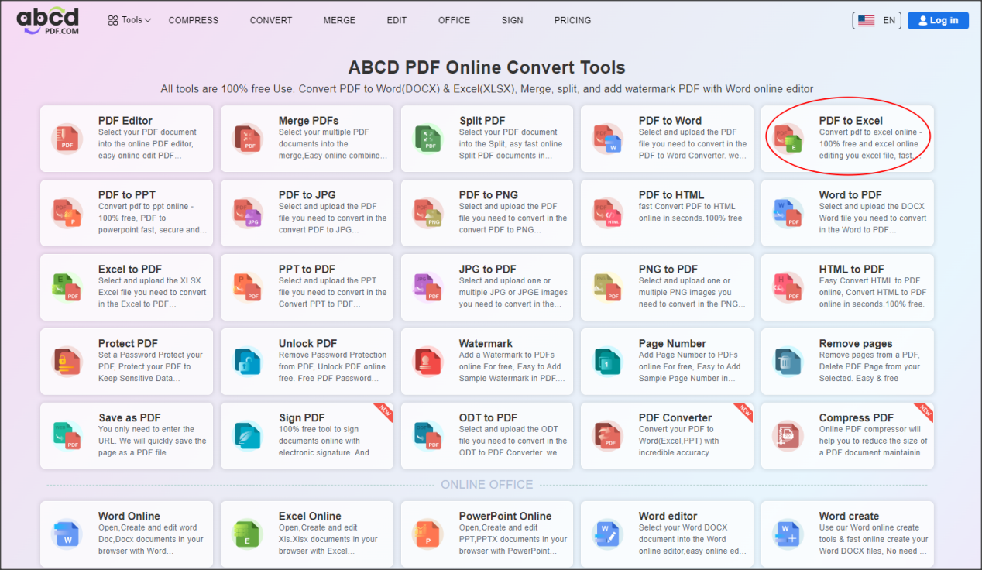

Step 2. Select the PDF file that needs to be converted locally and upload it.

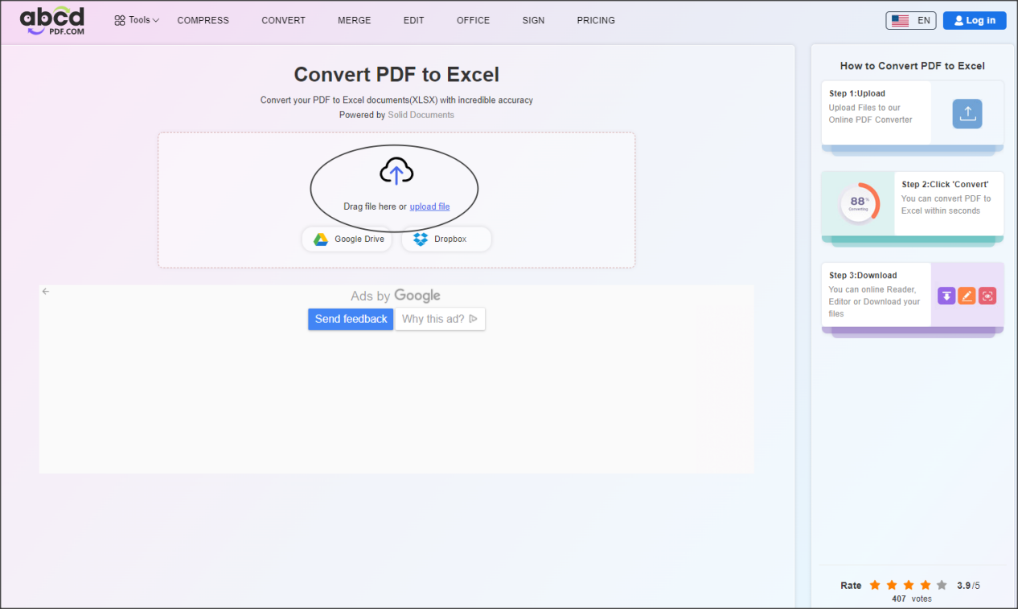

step 3. After the file is uploaded, select " Convert " to start converting.

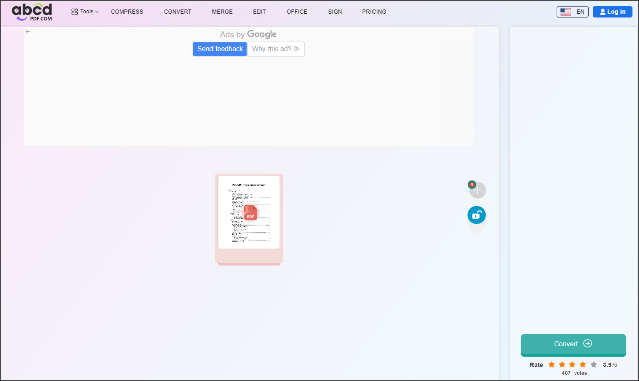

step 4. After the conversion is completed, select "Download" to save the Excel file locally.

PDF to JPG Convert Online

PDF to JPG Convert Online , as its name suggests, can convert PDF files into JPG images. JPG is a common image format. Although you can directly capture the required image from the PDF by taking a screenshot, it will inevitably be different from the actual PDF file in terms of clarity, size, and color. For professionals who want a unified conversion specification, it is better to use pdf to jpg convert online for pdf to jpg, which is a very good choice without downloading additional plug-ins and cutting them by hand.

Conversion steps:

Step 1. Log in to "AbcdPDF Platform".

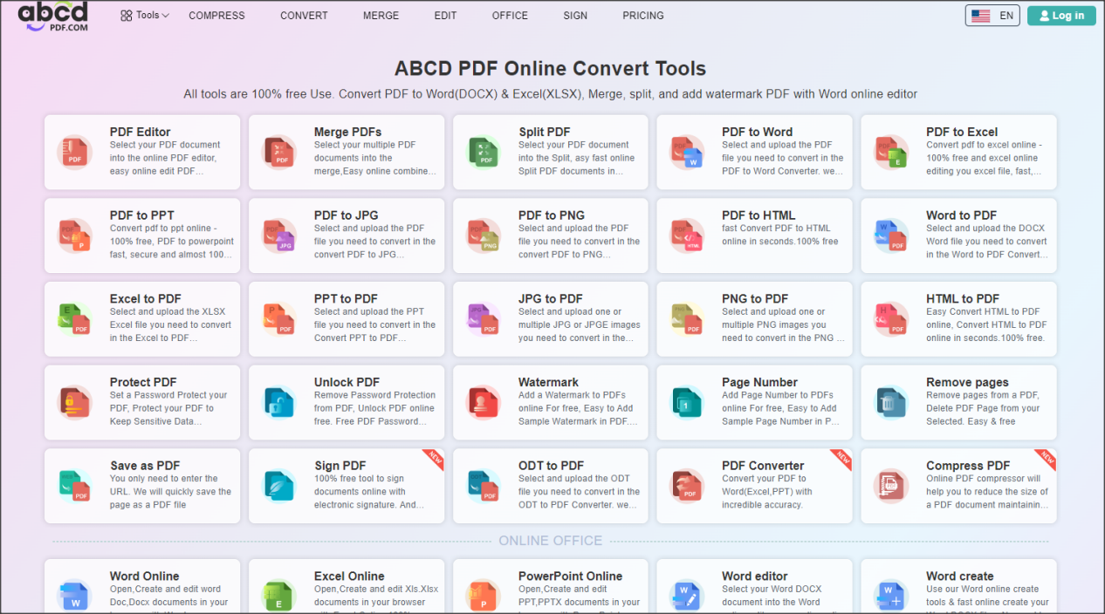

Step 2. Select "PDF to JPG".

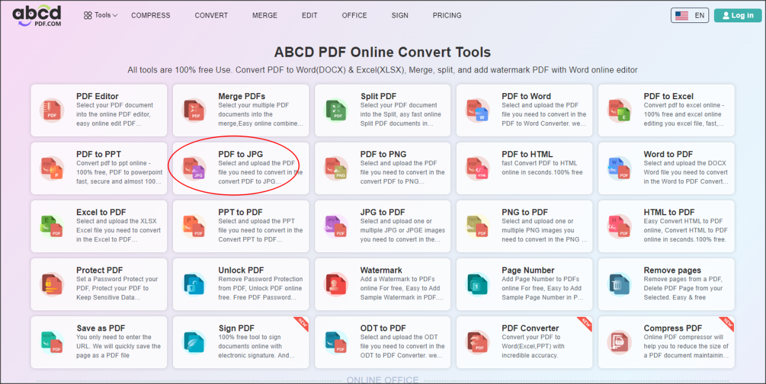

Step 3. Select "Select File" and upload the file.

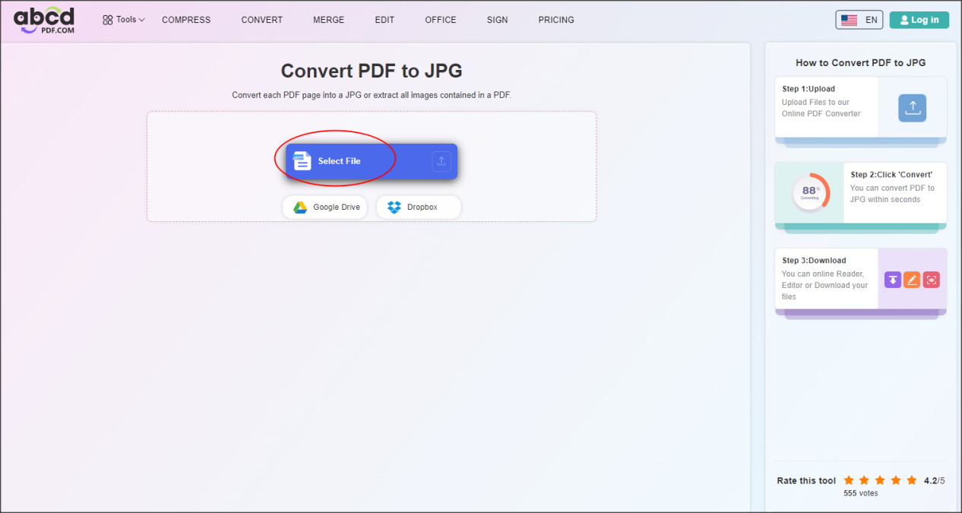

Step 4. Wait for the conversion to complete and click the "Convert" button at the bottom right.

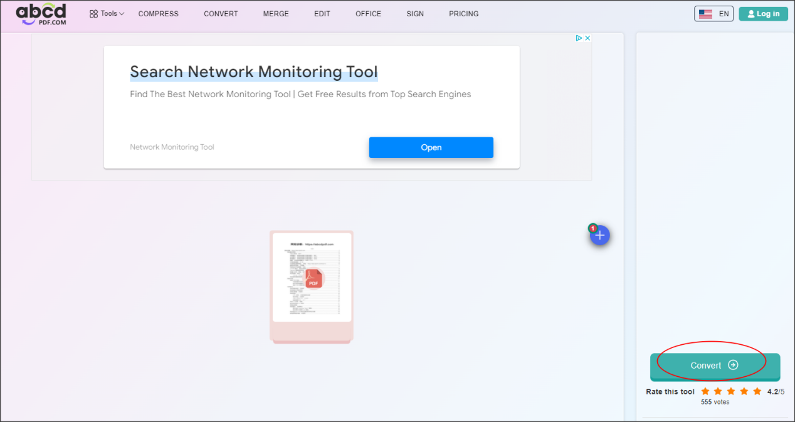

Step 5. Click "Download" in the lower right corner to download the converted JPG format to the local.

Note, if the PDF file you uploaded before is composed of multiple pages, the downloaded JPG file will also have the corresponding number of pages.

Summarize

PDF h ow to convert Excel, Jpg? The above content introduces you the characteristics of PDF and the methods of converting to Excel and JPG. These two conversion methods are operated w

